SCHOOL OF SCIENCE
DEPARTMENT OF CHEMISTRY

POSTGRADUATE PROGRAM
“INORGANIC CHEMISTRY AND ITS APPLICATIONS IN INDUSTRY”

RESEARCH DIPLOMA THESIS

Title

NAME AND SURNAME
AREA OF SPECIALIZATION (e.g., CHEMIST)

ATHENS
MONTH YEAR

RESEARCH DIPLOMA THESIS
Title

NAME AND SURNAME
R.N.: 000000000000000000000000000

THESIS COMMITTEE

DATE OF THESIS DEFENSE DD/MM/YEAR

ABSTRACT

SUBJECT AREA:
KEYWORDS: 5 keywords

ACKNOWLEDGEMENTS

CONTENTS
CHAPTER 1 [HEADING] 15
1.1 Basic concepts 15
1.2 Subheading 15
CHAPTER 2 [HEADING] 16
2.1 Subheading 16
2.2 Subheading 16
2.3 Subheading 16
2.3.1 Subheading 16
2.3.2 Subheading 16
2.4 Subheading 16
CONCLUSIONS 18
ABBREVIATIONS-ACRONYMS 19
APPENDIX I 21
APPENDIX II 22
REFERENCES 23

LIST OF SCHEMES
Scheme 1. Mechanism of catalytic alcohol oxidation Error! Bookmark not defined.

LIST OF FIGURES
Figure 1. Serene sunset 17

LIST OF TABLES
Table 1. Selected properties of the first-row d-block elements. 15

CHAPTER 1
[HEADING]
  - Basic concepts
The electron configuration and selected properties of the elements of the first-row d-block elements are presented in Table 1.
Table 1. Selected properties of the first-row d-block elements.
Element | Z | Electron configuration | Electronegativity | Metallic radius (nm) | Melting point (ºC) | Density (g cm⁻³)
Sc | 21 | [Ar]3d¹4s² | 1.36 | 0.162 | 1541 | 2.99
Ti | 22 | [Ar]3d²4s² | 1.54 | 0.147 | 1668 | 4.51
V | 23 | [Ar]3d³4s² | 1.63 | 0.134 | 1910 | 6.00
Cr | 24 | [Ar]3d⁵4s¹ | 1.66 | 0.128 | 1907 | 7.15
Mn | 25 | [Ar]3d⁵4s² | 1.55 | 0.127 | 1246 | 7.30
Fe | 26 | [Ar]3d⁶4s² | 1.83 | 0.126 | 1538 | 7.87
Co | 27 | [Ar]3d⁷4s² | 1.88 | 0.125 | 1495 | 8.86
Ni | 28 | [Ar]3d⁸4s² | 1.91 | 0.124 | 1455 | 8.90
Cu | 29 | [Ar]3d¹⁰4s¹ | 1.90 | 0.128 | 1085 | 8.96
Zn | 30 | [Ar]3d¹⁰4s² | 1.65 | 0.134 | 420 | 7.13
All elements except scandium can be found in the divalent state, corresponding
The first-row d-block elements can react with various chemical elements.
  - Subheading
Text text text

CHAPTER 2
[HEADING]
  - Subheading
Text text text
  - Subheading
Text text text
  - Subheading
Text text text
    - Subheading
Text text text
    - Subheading
Text text text
  - Subheading
Text text text
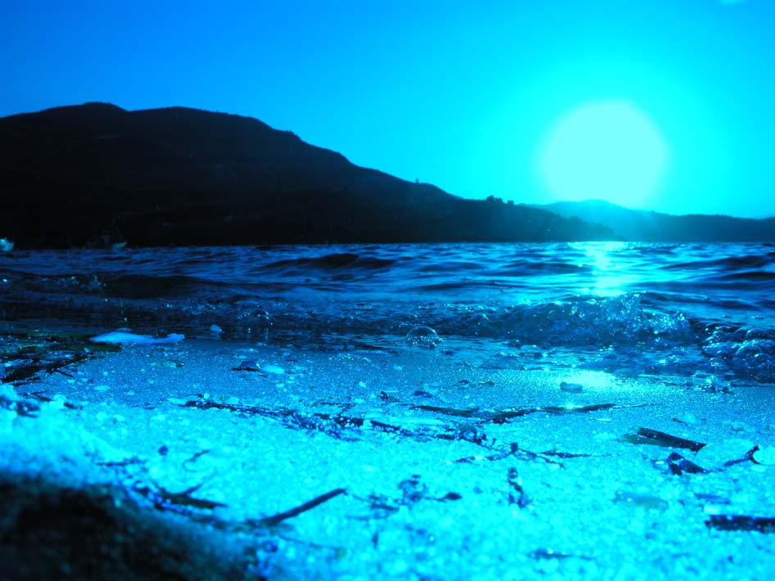
Figure 1. Serene sunset

CONCLUSIONS
Text text text

ABBREVIATIONS-ACRONYMS

APPENDIX I
Text text text

APPENDIX II
Text text text

REFERENCES
1. O'Garra, A.; Redford, P. S.; McNab, F. W.; Bloom, C. I.; Wilkinson, R. J.; Berry, M. P. R., The immune response in tuberculosis. Annu. Rev. Immunol., 2013, 31, 475-527.
2. Frieden, T. R.; Sterling, T. R.; Munsiff, S. S.; Watt, C. J.; Dye, C. Tuberculosis. Lancet 2003, 362, 887-899.
3. Koul, A.; Arnoult, E.; Lounis, N.; Guillemont, J.; Andries, K. The challenge of new drug discovery for tuberculosis. Nature 2011, 469, 483-490.
4. Smith, I. Mycobacterium tuberculosis pathogenesis and molecular determinants of virulence. Clin. Microbiol. Rev. 2003, 16, 463-496.

